TITLE
(capital letters, bold type, set in the middle of the text body, Cambria 14, one separation line between text)
Kowalczyk M. Author’s Name ( set in the left of the text body, Cambria 11)
Cracow University of Technology (workplace as University, set in the left of the text body, Cambria 11, one separation line between text)

Abstract: This paper contains results of researches of titanium alloy Ti-6Al-4V machined by polycrystalline diamond (PCD) tool in accordance with Hartley experiment design (PS[DS.-P:Ha3). Xxxxxxxxxxxxxxxxxxxxxxxxx. (italic, Cambria 11, this line is minimum for abstract in English 10 lines, one separation line between text)

Keywords: chip compression ratio

It should be typed on A/4 size white copy paper (margins: top 7,69cm, left and right 4 cm, bottom 3,5 cm). (Cambria font type, size 11).
Please, do not number the pages!!!

Introduction (paragraph – No numbering, separation after text 6pt)
Titanium alloys are extremely difficult to cut material. It can be explained by the physical, chemical, and mechanical properties of the metal [5,8,12]. Titanium and titanium alloys have low thermal conductivity and high chemical reactivity with many cutting tool materials. Xxxxxxxxxxxxxxxxx[8,11].

(one separation line between text and pictures)
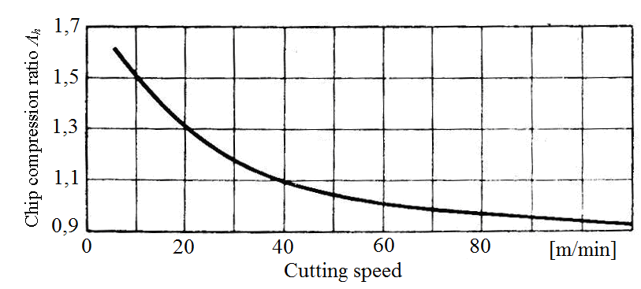
Figure 1. Influence of cutting speed and feed on chip compression ratio _{h} when titanium alloy machining with sintered carbides tools (cutting geometry: =12º, =0º,=45⁰, ’=10º, f_{n}=0,2 mm[obr, a_{p}=1,5 mm) [4].
(Cambria 10)( set in the middle of the text body, separation before text for figures 6pt)
one separation line between text
Xxxxxxxxxxxxxxxxxxxxxxxxxxxxxxxxxxxxxxxxxxxxxxxxxxxxxxxxxxxxxxxxx

The velocity of chip flow over the rake face is calculated based one of the following formula:
v_{ch}=v_{c}/Ʌ_{h} (1)

Formula should be set in the middle and the height of the characters should be identical to that of the letters in the text. Formulae should be numbered in parentheses, with a blank line preceding and following them.

Table 3. Geometry of cutting edge.
Kind of tool | Geometry
(Table: Cambria 10, one separation line between text)
Xxxxxxxxxxxxxxxxxxxxxxxxxxxxxxxxxxxxxxxxxxxxxxxxxxxxxxxxxxxxxxxxxxxxxxxxxxxx

Conclusion
Xxxxxxxxxxxxxxxxxxxxxxxxxxxxxxxxxxxxxxxxxxxxxxxxxxxxx.

References
- CHE-HARON C.H., JAWAID A.: The effect of machining on surface integrity of titanium alloy Ti–6% Al–4% V. (2005), Journal of Materials Processing Technology vol. 166 , pp. 188–192.

