Building a 2D simulation model for turning using the Abaqus application
– Stage two

Exercise stages:
Stage two

define constraints interactions between the model elements,

define boundary conditions make an assembly,

interpretation of the machining simulation.

Define constraints interactions between the model elements

In the first step, before you define interactions between the cutting tool and the workpiece, you need to separate a part from the machined material which is located the nearest the machining process. Open the workpiece in the ‘Part’ and from the ‘ToolBox’ zone select ‘Create Partition’ and check relevant options in the opened panel (Fig. 1.1). The software will automatically create a sketchpad to make changes in the workpiece geometry. Then, use the “Create Lines: Rectangle (4 Lines)’ and draw a 2.4 mm x 0.4 mm rectangle on the workpiece top. The model after correct operations is shown in Fig. 1.2.

Fig. 1.1 Partition parameters | Fig. 1.2 View after separation of a fragment

In the next step, define interactions between the modelled elements. Open the ‘Interaction’ module and use the ‘Create Interaction Property’ function to define the contact interaction. In the displayed panel, check the setting shown in Fig. 1.3 and click ‘Continue’ to accept. In the next panel ‘Edit Contact Property’ in the ‘Mechanical’ category click ‘Normal Behavior’, select the function ‘Allow separation after contact’. Add also ‘Tangential Behavior” from the ‘Mechanical’ category, and changing ‘Friction formulation’ to ‘Penality’, in the ‘Friction Coeff’ column enter 0.1. The last parameter to be added is ‘Heat Generation’ from the ‘Thermal’ list where you do not change the settings.
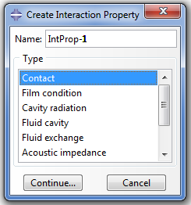
Fig. 1.3 Create contact interaction

The next operation is to apply interaction between respective planes. Use the ‘Create Interaction’ tool’ and check the correct options in the panel according to Fig. 1.4, and click ‘Continue’ to accept.
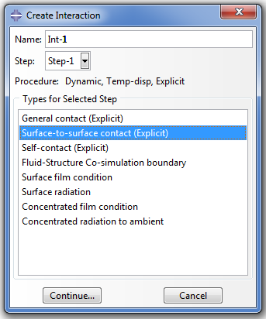
Fig. 1.4 Define interactions between planes
Close the ‘Create Interaction’ window, the command ‘Select first surface’ will appear in the bottom part of the screen; you need to check the clearance edge and rake edge (Fig. 1.5) and press ‘Done’ to confirm. The next command will be ‘Choose the second surface type’: from the options on the bar in the bottom part of the screen select ‘Node Region’ and highlight the top part of the workpiece (Fig. 1.6), then press ‘Done’.

Fig. 1.5 Selected edges | Fig. 1.6 Determine the interaction area

When you have checked appropriate elements in previous steps, the ‘Edit Interaction’ panel will appear: the options selected there initially will remain the same.
In the next step required for correct simulation, create a reference point on the tool surface to define the tool motion. To do so, click ‘Tool’ in the top part of the screen and use the ‘Reference point’ command to select the place shown in Fig. 1.7.

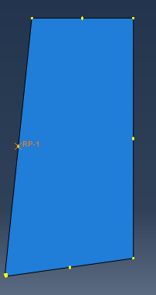
Fig. 1.7 Create a reference point on thee tool surface

The previous operations will allow defining some constraints. Start defining by selecting the ‘Create Constraint’ tool and in the ‘Tape’ place check ‘Rigid Body’ and click ‘Continue’. The ‘Edit Constraint’ panel will open as shown in Fig. 1.8. Highlight ‘Body’, select the symbol and mark the cutting tool part which will change to red, then press ‘Done’ to complete. When you are back in the ‘Edit Constraint’ panel, click the cursor symbol located here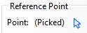 and mark the previously created reference point. Press ‘OK’ to save all changes made. The screenshot after correct operations is shown in Fig. 1.9.

Fig. 1.8 Edit Constraint panel | Fig. 1.9 Defined interactions

Define boundary conditions

The turning process simulation requires a fixing of one of the elements of the arrangement, the workpiece in this case. To define this parameter, you need to use the ‘Load’ module and then the ‘Create Boundary Condition tool. Check the parameters in the panel on the screen as shown in Fig. 1.10.

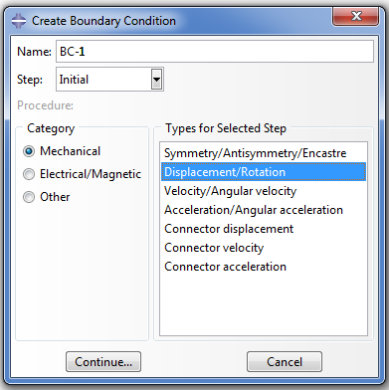
Fig. 1.10 Options selected during the definition of boundary conditions

Press ‘Continue’ to go further; the ‘Select regions for the boundary condition’ command will appear in the bottom of the screen where you need to select elements to create constraints. Holding the ‘Shift’ key depressed, select as shown in Fig. 1.11 Press ‘Done’’ to accept, the ‘Edit Condition’ panel will be displayed. Make changes according to Fig. 1.12 and click ‘OK’ to accept.
Fig. 1.11 Selected constraints locations | Fig. 1.12 Selected parameters in edition

The next step in creating boundary conditions is to define the constraints for the cutting tool. Again use the ‘Create Boundary Condition’ tool, but this time in ‘Types for Selected Step’ select ‘Velocity/Angular velocity’. When the ‘Select regions for the boundary condition’ command appears, mark ‘RP-1’ on the cutting tool edge and click ‘Done’ to accept. In the new window ‘Edit Boundary Condition’ check the parameters and enter values shown in Fig. 1.13.

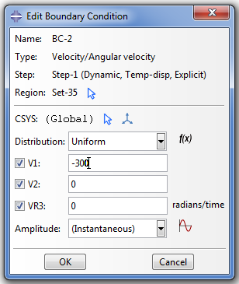
Fig. 1.13 Enter values for selected parameters

Define the amplitude in the next step: select symbol 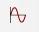 and check the ‘Smooth step’ option in the ‘Create Amplitude’ panel. You will go to the ‘Edit Amplitude’ panel where you need to make changes according to Fig. 1.14.

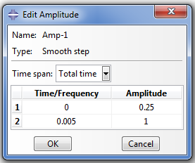
Fig. 1.14 Define Amplitude

If you have made previous operations correctly, the assembly view will change and will look as shown in Fig. 1.15.

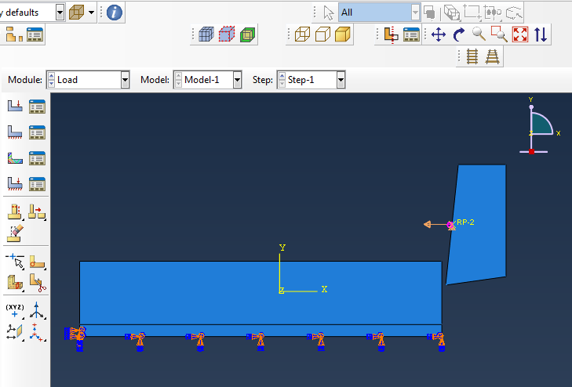
Fig. 1.15 Correctly applied constraints

Use the mesh for the individual model parts

The final stage of the model design is to define the mesh. In this software, the mesh has to be applied on each element separately. The sequence of elements is arbitrary. To define the mesh in the tool, open the ‘Part’ category in the “model tree,” and go to ‘Ostrze’ [blade], and click ‘Mesh’ in the ‘Module’ bar. The mesh is defined according to the FEM rules. The designed cutting tool model is perfectly rigid, so it will not be analysed for impact of factors, allowing the mesh to be created with as few elements as possible. To create the cutting tool mesh, use the ‘Seed Part’ tool to open the ‘Global Seeds’ panel and make changes in this panel as shown in Fig. 1.16, and then press ‘OK’ to finish. The next tool needed to achieve this goal is the ‘Mesh Part’ 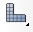 which in the bottom part of the screen will display the question ‘Mesh Part?’. Click ‘Yes’ to change the element colour and apply the mesh as shown in Fig. 1.17.

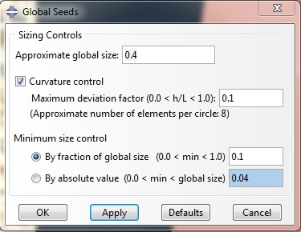  Fig. 1.16 Define the mesh parameters | Fig. 1.17 Mesh applied on the tool

Now, create the mesh for the workpiece. Similarly to the cutting tool, open the ‘DetalObrabiany’ [workpiece] model and go to the ‘Mesh’ module. Because this element is divided into a few fragments, in this case you need to use another tool called ‘Seed Edges’ 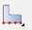 to display the command ‘Select the regions to be assigned local seeds’ where you need to mark the workpiece edge to create the mesh (Fig. 1.18). Then, click ‘Done’ to confirm.

Fig. 1.18 Select the edge to create the mesh in the first fragment
To continue, open the ‘Local Seeds’ panel to define the mesh parameters. In ‘Approximate element size’ change the value to 0.035 (Fig. 1.19) and leave the default values of other parameters.

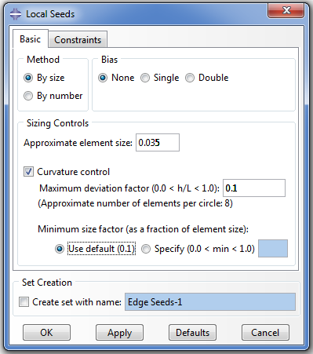
Fig. 1.19 Mesh parameters for the first fragment
Perform identical operations to create the mesh for the second workpiece fragment, except mark the line as shown in Fig. 1.20 and change the ‘Approximate element size’ parameter to 1.

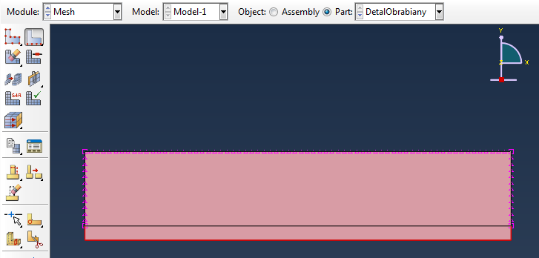
Fig. 1.20 Select the edges to create the mesh in the second fragment

After you have designed the mesh for the workpiece in previous steps, now you need to apply it using the ‘Mesh Part’ tool and accept by pressing ‘Yes’. When you have done the steps correctly, the image should be as shown in Fig. 1.21.

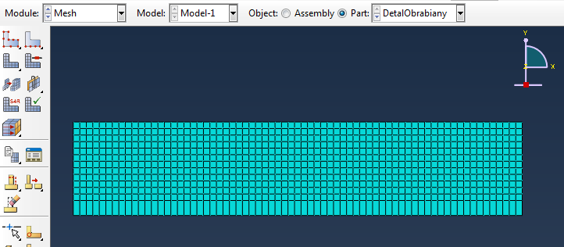
Fig. 1.21 Mesh on the workpiece
A very important element for an appropriate simulation is also the application of correct parameters in the ‘Element Type’ panel in the dropdown ‘Mesh’ tab in the main menu. The options checked in Fig. 1.22 and the entered values must be defined for both the workpiece and the cutting tool models.

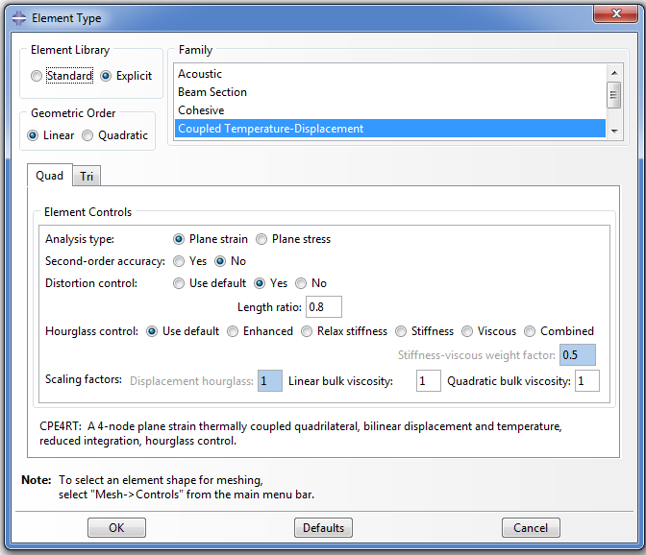
Fig. 1.22 Checked parameters and entered values in the element settings

Interpretation of the machining simulation

In the Abaqus application, make nine 2D simulations of the machining process for varying cutting speeds and feedrates. The used values are presented in Table 2.1.
Table 2.1 Parameters applied during the machining simulation
Simulation | f [mm] | $v_{c}$ [m/min] | $v_{c}$ [mm/s]
Sim1 | 0.153 | 18 | 300
Sim2 | 0.153 | 25 | 417
Sim3 | 0.153 | 32 | 533
Sim4 | 0.230 | 18 | 300
Sim5 | 0.230 | 25 | 417
Sim6 | 0.230 | 32 | 533

Due to the system of units of measure in the Abaqus application, the feedrate had to be entered in ‘mm/s’. The workpiece dimensions used for simulation were 2.4 mm x 0.5 mm. The cutting tool geometrical parameters were constant, and the values of the clearance angle α and the tool rake angle γ were 8°, 6°. Tasks to be performed:
Determine: the distribution of stresses according to Hubert-Mises, the temperature distribution in the cutting zone during the turning, – an example distribution is shown below:
a) | b)
c) | d)
Fig. 2.1 Distribution of stresses in the machined material in selected steps for cutting speed of 18m/min and feedrate of 0.230
a) 2nd simulation step b) 4th simulation step c) 6th simulation step d) 8th simulation step
a) | b)
c) | d)
Fig. 2.2 Temperature distribution in the machined material in selected steps of cutting speed of 32m/min and feedrate of 0.153 mm/ rev.
a) 2nd simulation step b) 4th simulation step c) 6th simulation step d) 8th simulation step

